PRACTICAL- 4 ( WIKIPEDIA)

1. What is Wikipedia?

Wikipedia is an online free content encyclopedia project helping to create a world in which everyone can freely share in the sum of all knowledge. The project is supported by the Wikimedia Foundation and based on a model of freely editable content. The name "Wikipedia" is a blending of the words wiki (a technology for creating collaborative websites, from the Hawaiian word wiki, meaning "quick") and encyclopedia. Wikipedia's articles provide links designed to guide the user to related pages with additional information. Wikipedia is written collaboratively by largely anonymous volunteers. Anyone with Internet access can write and make changes to Wikipedia articles, except in limited cases where editing is restricted to prevent further disruption or vandalism. Since its creation on January 15, 2001, Wikipedia has grown into the world's largest reference website, attracting 1.7 billion unique-device visitors monthly as of November 2021. It currently has more than fifty-eight million articles in more than 300 languages, including 6,457,103 articles in English with 132,609 active contributors in the past month. Wikipedia is a live collaboration differing from paper-based reference sources in important ways. It is continually created and updated, with articles on new events appearing within minutes, rather than months or years. Because everybody can help improve it, Wikipedia has become more comprehensive than any other encyclopedia. Besides quantity, its contributors work on improving quality, removing or repairing misinformation, and other errors. Over time, articles tend to become more comprehensive and balanced. However, because anyone can easily add content at any time, any article may contain undetected misinformation, errors, or vandalism. Readers who are aware of this can obtain valid information, avoid recently added misinformation (see Wikipedia:Researching with Wikipedia), and fix the article.

1. Steps to create an account on Wikipedia:

Step 1. Search on browser as “WIKIPEDIA”

Step 2. Click on given link and click on “CREATE ACCOUNT”

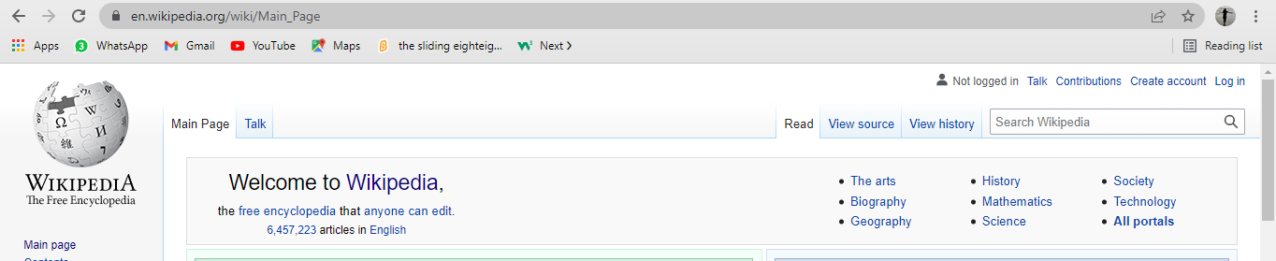

Step 3. Fill up your all details.

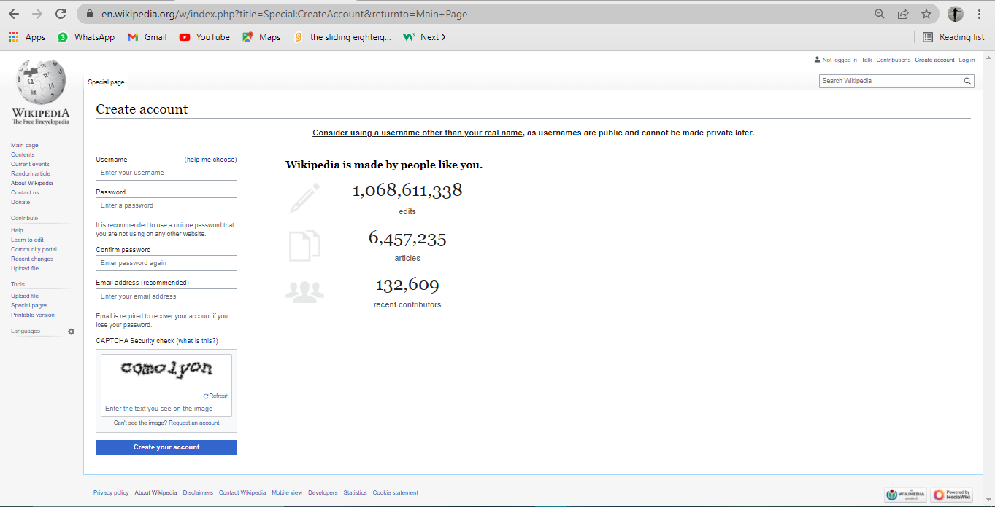 Step 4. Click on “CREATE ACCOUNT”.

Step 5. Your account is created.

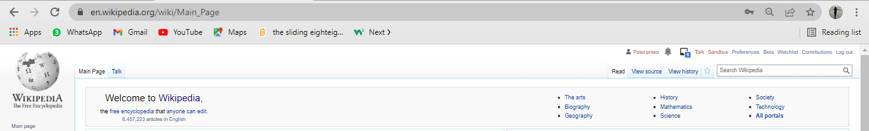

1. Creating a page on Wikipedia.

Step 1. To create page click on “SANDBOX”.

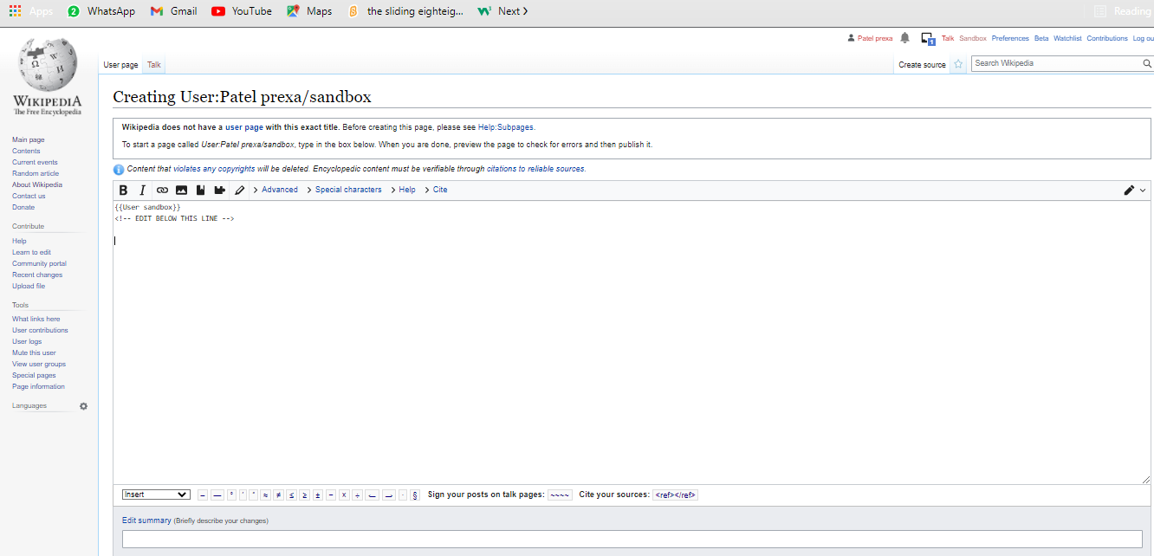step 2. Type your information in the sandbox.

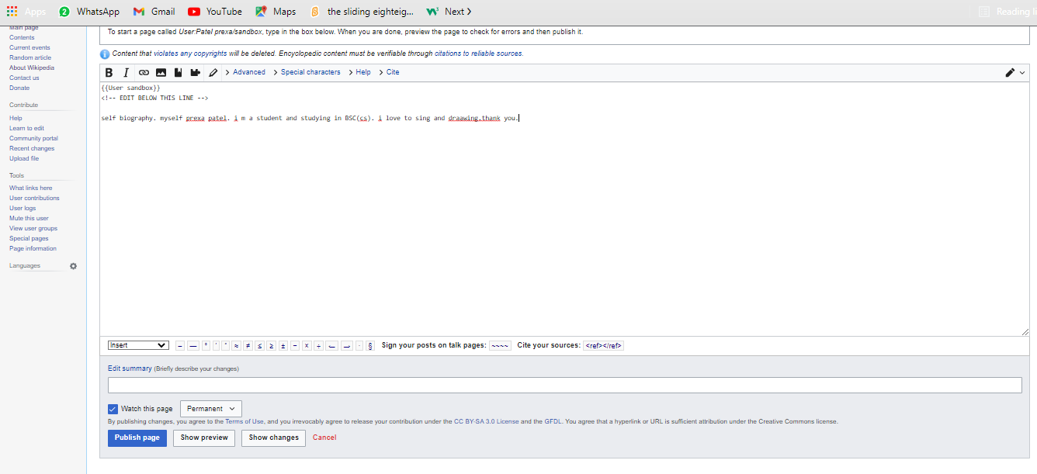Step 3. After typing your information then click on “PUBLISH PAGE”.

Step 4. Your page is created.

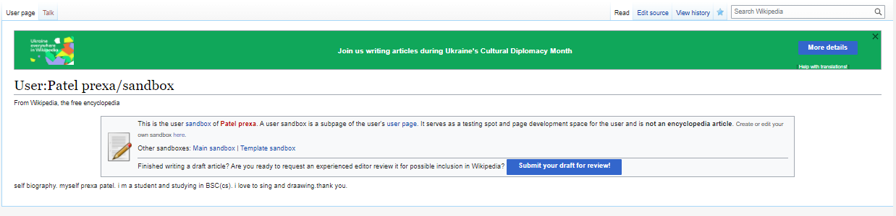

1. Edit your page.

Step 1. To edit the created page click on “EDIT SOURCE”.

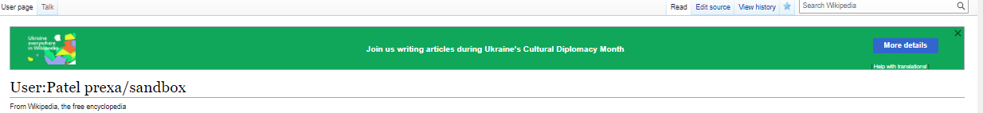

Step 2. After clicking on edit source start your editing.

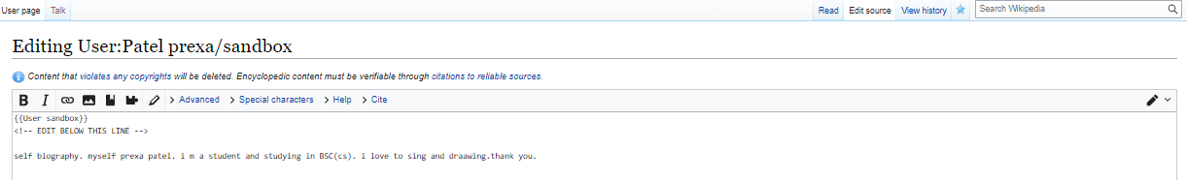

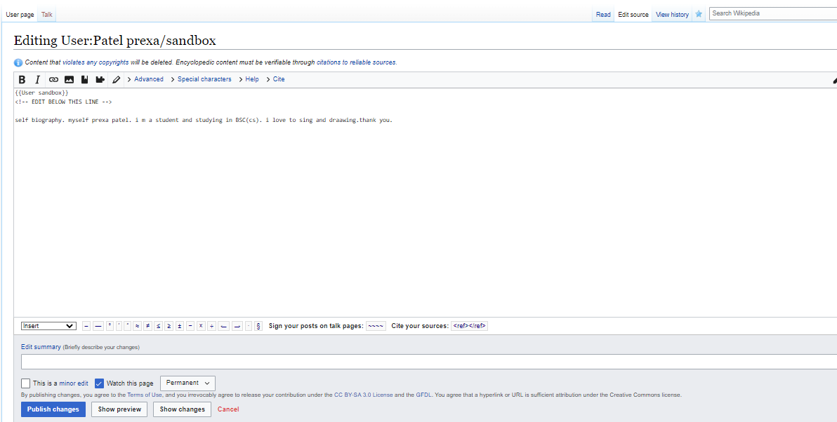Step 3. After complete editing your page click on “PUBLISH CHANGES”.

Step 4. And your page is edited.

